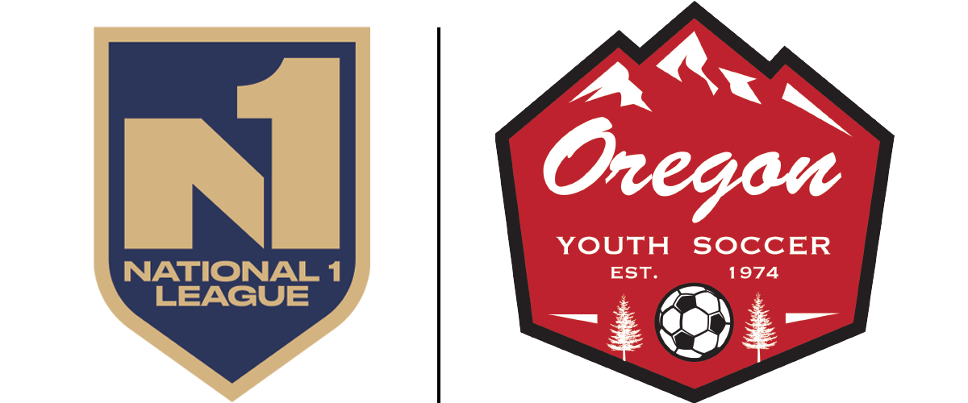

National 1 League Standards
By applying to be a part of the National 1 league you are making a commitment to elevate the standards of play across the state of Oregon. The standards listed below will be required for every team submitting a successful application into the league.
League standards will be discussed and improved upon by a dedicated group of club leaders represented within National 1.

GAME DAY STANDARDS
The following will be required to participate in National 1
- 15 player minimum rosters before team can be activated. Rosters may have 30 players max
- Home team to provide corner flags, canopies and benches for both teams
- Home team to provide canopy and bench for the referee crew
- Games to be played on turf
- All fields will match approved sizing for each age group

RECORDS & TRAINING
- Home team must record the game
- Game footage to be uploaded within 36 hours to League Exchange
- League Exchange library to be provided by OYSA via Veo*
*You do not need to be a Veo customer. Trace, HUDL, and other formats may be used and uploaded

OFFICIATING
- There will be 3 officials managing every game
- There will be a referee mentor at every game

COACHES
- All head coaches will hold a minimum of a D-license and be present at the game.
- All assistant coaches will hold a minimum of a grassroots license in year one, with year two expanding to a D-license
CONTINUING EDUCATION
- All coaches (head and asst) will maintain a minimum of 5 hours of approved 'continuing education’ through approved sources

SEASONAL FORMAT
- U13 & U14: 20 game season (Sept - April)
- U15 - U19: 12 game season (Jan - April)
- Single game weekends where possible. Requests considered for geography.
- All games kick off between 9am and 3pm on Saturday

SCHEDULING
- You will be provided with your schedule for the year in mid/late August 2026.
- Games later in the season without field availability will be published, and teams will be given up to 21 days prior to kick off to provide a field. If no field is provided by home team, the away team will be given rights to host until 14 days prior to kick off. Games left without a field less than 13 days prior to kick off will have a field assigned to them by League Operator. Home team will be charged for that field.

SIDE NOTE: WHAT ABOUT THE U11 & U12 AGE GROUPS?
- Across the nation, National 1 is for U13 and older teams
- At 10 and 11 years old we believe local games serve the families best. Play local, stay local
- We will be introducing some of the standards listed here into our U11 & U12 age groups
- In these age groups, we will be continuing with our PCL/SCL/RCL model

REGISTRATION PLATFORM
- National 1 will be registered through US Club Soccer
- National 1 will be administered through the GOTSport platform

PLAYER ELIGIBILITY
- Any player appearing on an ECNL roster is not eligible for National 1
- A maximum of 4 ECNL/RL players are allowed to be on a National 1 roster.
- MLS/GA and other non-ECNL league players are eligible for participation

POST-SEASON
- Teams that win their division in National 1 are eligible to participate in the ENCL Conference League Playoffs as district league qualifiers
- Finishing last in the division may result in relegation from National 1
- National 1 teams may play State Cup or Presidents Cup. They may not play Founders Cup

NEW COMP COST
- U13 & U14 for a 20 game season will be $2250**
- U15 - U19 for a 12 game season will be $1550**
**A $380 discount will be given for any team that registers their players with USYS in addition to National 1

